Immigration is speeding up Australia's population growth

David Scutt
Mar 22, 2018, 2:18 PM

 Photo: Getty Images
- Australia’s population grew by 395,600 to 24.7 million in the 12 months to September.
- Net overseas migration rose by 250,100 people, outpacing a 145,500 contribution by natural increase.
- Population growth is strongest in the eastern states, especially in Victoria.

Australian population growth continued to accelerate in the 12 months to September, driven predominantly by immigration with much of it driven by student visa applications.
According to the Australian Bureau of Statistics (ABS), Australia’s population grew by 395,600 over the year to 24.7 million, representing an increase of 1.63%.
In the September quarter alone, population rose by 103,900, or 0.42%.
Over the year, net overseas migration rose by 250,100 people, accounting for 63.2% of Australia’s total population growth.
That was up 33,400, or 15.4%, on the level reported in the year to September 2016.
Arrivals rose 7.1% to 551,000, the highest level on record. Over the same period, departures grew by a smaller 1.1% to 300,800.
Natural increase — measuring births less deaths — contributed the remaining 36.8% of the increase, slowing to 145,500, below the levels seen in prior years.
This chart from the Commonwealth Bank shows the breakdown in population growth by net overseas migration and natural increase going back to the year 2000.
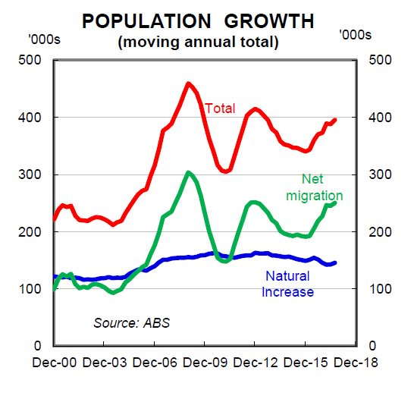Source: Commonwealth Bank
As natural increase has slowed in recent years, migration has accelerated.
“The migrant intake is generally skewed towards skilled migrants rather than unskilled migrants,” said Belinda Allen, Senior Economist at the Commonwealth Bank.
As seen in the next chart, also from CBA, much of the recent acceleration was due to a sharp lift the number of foreign students studying in Australia.
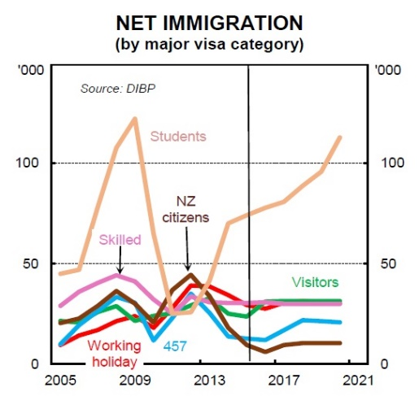Source: Commonwealth Bank
“Student visa applications remain the key driver of net immigration and will continue to do so over coming years,” said Allen. “Student visa applications lodged for the six months to 31 December 2017 rose by 14.1%.”
And, according to the Australian government, that recent trend will continue in the years ahead.
“Department of Immigration and Border Protection forecast Net Overseas Migration (NOM) will rise be 7.6% by June 2020,” Allen says. “Much of the increase in NOM is expected to be driven by rising student numbers.”
By state and territory, the ABS said much of the national increase in population was concentrated along the eastern seaboard.
“Victoria continued to close the population gap on New South Wales and was the fastest growing state or territory with a population increase of 2.37%, followed by the Australian Capital Territory at 1.77%,” said Anthony Grubb, ABS Demography Director.
By number, Victoria’s population rose by 147,400 over the year, far outpacing the levels seen in other parts of the country.
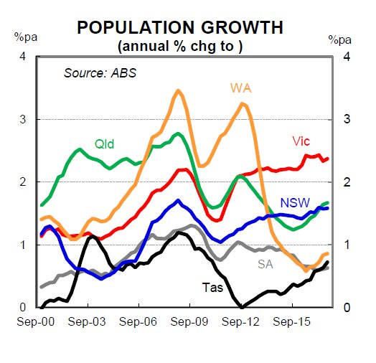Source: Commonwealth Bank
New South Wales and Queensland also logged increases of 1.58% and 1.67% respectively, lifting by 123,100 and 81,300 from 12 months earlier.
In other parts of the country, the growth rates recorded were significantly lower, ranging from flat in the Northern Territory to 0.9% in Western Australia.
This table from the ABS shows the change in population by state and territory in detail.
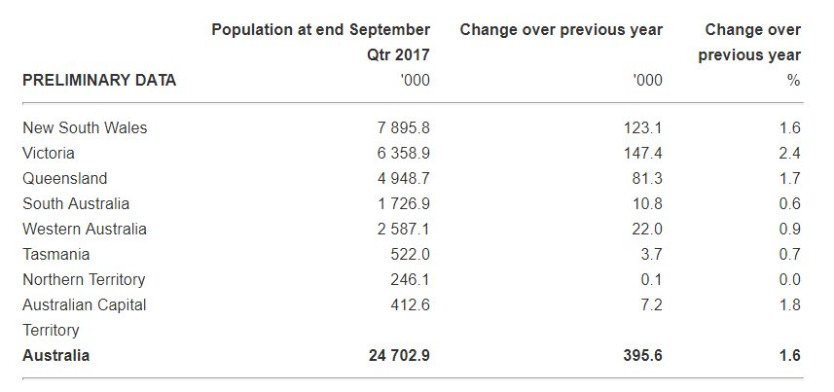Source: ABS
While stronger population growth has helped to boost employment and underpin economic activity since the GFC, there are growing concerns that Australia is currently growing too fast for existing infrastructure to keep up, leading to overcrowding of schools, hospitals and public transport, higher housing costs and slow growth in worker wages, among other economic.
And then there’s environmental and social aspects, which we’ll leave for another day.
https://www.businessinsider.com.au/australia-population-growth-immigration-dick-smith-2018-3

